Luella (Loup) Burch

May 4, 1921 – December 26, 2007

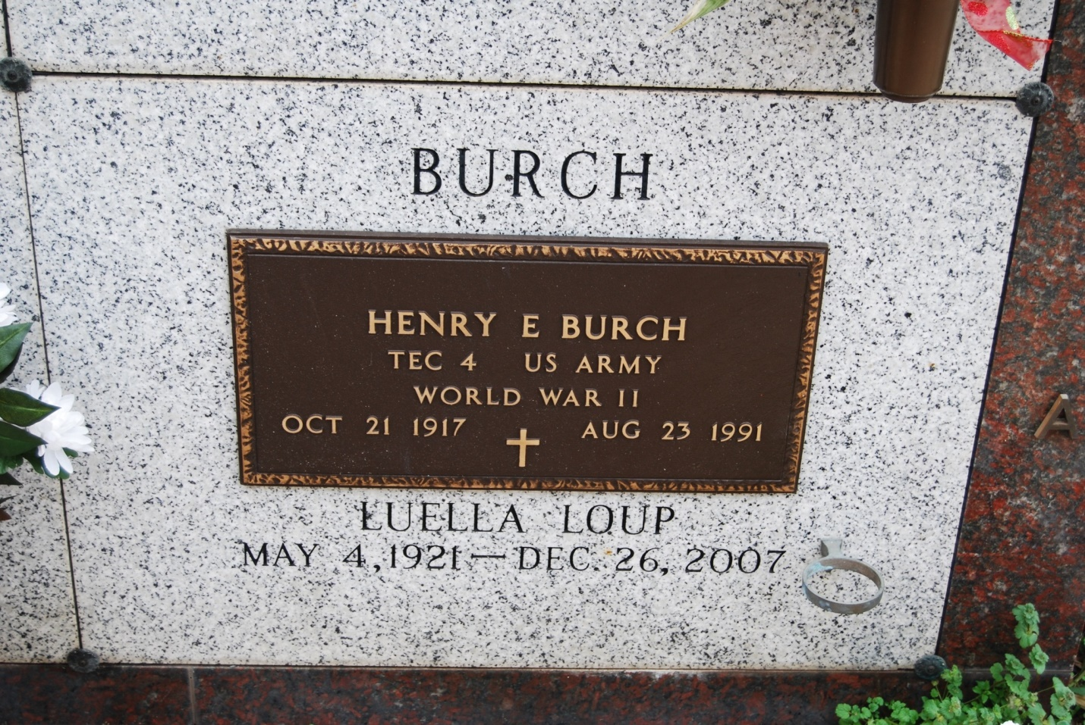

Photo by Kerry Keller

Luella Loup Burch died on Wednesday, Dec. 26, 2007 in Houma, LA at the age of 86. Wife of the late Henry Burch. Daughter of the late Pascal Loup & Emelie Roussel Loup. Mother of Vicki Burch Beadle and husband Robert Beadle of Reserve, LA and Monica Burch of Thibodaux, LA. Grandmother of Jaime Beadle. Sister of the late Nemour Loup, Felician Loup, Ferdinand Loup, Roy Loup, Clemence Waguespack, Loulutte Hymel and Velma Biondello. A native and former resident of Wallace, LA and current resident of Houma, LA.

Visitation will be held Saturday, Dec. 29, 2007 at St. Philip Catholic Church, Vacherie, LA from 9 am until Mass of Christian burial at 11 am. Entombment will follow in the church mausoleum.

Alexander Funeral Home of Lutcher in charge of arrangements.

Times-Picayune, New Orleans, LA

Friday, December 28, 2007, p. 5